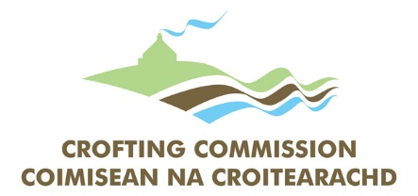

Complaints Form
You may wish to use this form to make a formal complaint to the Crofting Commission
Your Details
Surname: |  |  |  |  |  | Title:
Forename(s):
If you would like to remain anonymous, please tick here:
If the box is checked, no record of your name will be attached to the complaint
Postal Address:
 |  |  |  |  | Post Code:
Telephone:
Alternative Telephone:
E-mail Address:
I agree to communication by e-mail |  |  |  |  |  |  | Yes No
Croft Details (if applicable)
Croft Name
Croft Ref Number: |  |  |  | Main Location Code: |  |  |  |  |  |  | /
Privacy Notice
The Crofting Commission takes the protection of your privacy seriously. To safeguard your personal data and make sure that it is accurate, we only collect and/or store the data necessary to carry out our functions as a regulatory body. In this case, the processing is necessary to allow us to perform an official public authority function. You can find a copy of our Privacy Notice at www.crofting.scotland.gov.uk/openness-and-customer-care.
My complaint concerns (please tick all that apply):
 | Policy & Procedure |  | Service Delivery
 | Personnel |  | Commissioners
Nature of your Complaint (please tick all that apply):
 | Service not delivered on time |  | Wrong or misleading information
 | Received poor quality service |  | Complaint about staff member
 | Other (please specify on next page)

Please set out facts in a chronological order and remember to include important details and dates, where possible (continue on a separate sheet if necessary).
Signature: |  | Date:

Please return your form to:

‘Complaints’, Crofting Commission, Great Glen House, Leachkin Road, Inverness IV3 8NW or save this document to your computer and e-mail as an attachment to complaints@crofting.gov.scot with ‘Complaint’ in the subject heading.

