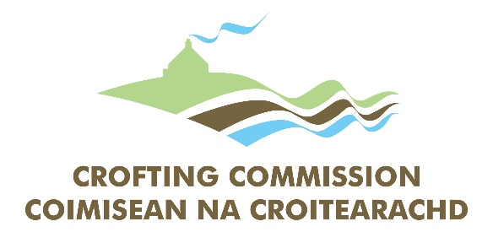

GAELIC LANGUAGE PLAN

2020-2025

This plan has been prepared under Section 3 of the Gaelic Language (Scotland) Act 2005

Approved by Bòrd na Gàidhlig on 27 October 2020
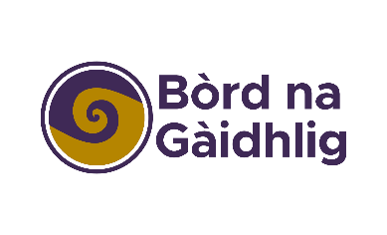
FOREWORD
As Chief Executive Officer of the Crofting Commission, I am pleased to introduce the third edition of our organisations’ Gaelic Language Plan. As the public regulator of the unique crofting system, I want to ensure that our organisation is doing all it can to encourage and promote Gaelic’s place in Scottish life.

The Gaelic language has helped to shape crofting over generations and shares with crofting a resilience that learns from the past while engaging with the future.

The Crofting Commission has, of course, a statutory duty under the Gaelic Language (Scotland) Act 2005 to play its part in promoting the language, but the unique link with crofting gives us an additional responsibility, as well as enthusiasm for this task.

This Plan sets out a formal structure for our support of the Gaelic language, with new initiatives and clear targets, reflecting a strong commitment throughout the Commission to see Gaelic thrive.

Since joining the Crofting Commission in 2016, I have very much enjoyed participating with staff in Gaelic Learning classes and welcome the inclusion of Gaelic language greetings at every Board meeting and our larger stakeholder meetings.

The current Board is committed to supporting the Gaelic language in the Crofting Counties, and together we continue to make our materials and all engagement with customers accessible to Gaelic speakers.

Bill Barron
Chief Executive
Crofting Commission
19 May 2020

CONTENTS

SUMMARY 1
INTRODUCTION 2
The Crofting Commission 2
Structure 2
The Gaelic Language (Scotland) Act 2005 And the Issuing of Notice 2
Approval of The Crofting Commission Gaelic Language Plan 3
Consultation on A Draft Gaelic Language Plan 3
Gaelic In Scotland 3
Gaelic Within the Commission’s Area of Operation 4
Gaelic Within the Crofting Commission 5
Internal Gaelic Capacity Audit 5
THE GAELIC LANGUAGE PLAN IN THE CORPORATE STRUCTURE 7
Position with Operational Responsibility Over the Plan 7
Position with Day to Day Responsibility Over the Plan 7
Group Overseeing Development, Implementation and Monitoring Of The Plan 7
Individual Staff Members 7
Services Delivered by Third Parties and Arm’s Length Organisations 7
PLANNING AND POLICY IMPLICATIONS FOR GAELIC 8
Mainstreaming Gaelic 8
The National Gaelic Language Plan 8
Scottish Government National Priorities 10
PLAN COMMITMENTS 11
High Level Aims 11
Corporate Service Aims 13
Status 14
Staff 15
Communicating with The Public 17
Information 20
Corpus 22
IMPLEMENTATION AND MONITORING 24
Timetable 24
Publicising the Plan 24
External 24
Internal 24
Resourcing the Plan 24
Monitoring the Implementation of the Plan 24
APPENDIX 1 26
INTERNAL GAELIC CAPACITY AUDIT 26

SUMMARY
This document has been prepared within the framework of the Gaelic Language (Scotland) Act 2005. It sets out how the Crofting Commission will promote the key over- arching principle of equal respect for Gaelic, showing how the organisation will work actively to encourage the use of the language and work towards longer-term developments, to enhance the use of Gaelic by the authority and improve customer service.

INTRODUCTION

The Crofting Commission
The Crofting Commission is a NDPB (non-departmental public body) and it is the regulator of crofting. It is working to secure the future of crofting by creating and promoting a well regulated crofting system that positively contributes to the sustainability of rural communities.

Crofting is a system of landholding unique to the Highlands and Islands of Scotland. A croft is a relatively small agricultural land holding, 5 hectares on average, and is usually held in tenancy. It may or may not have buildings or a house associated with it. Approximately 21,000 crofts, occupied by an estimated 10,000-12,000 crofting households, account for a total population of about 33,000.

The Crofting Commission was established in 2012 to administer the Crofters (Scotland) Act 1993 as amended by the Crofting Reform (Scotland) Act 2007 and the Crofting Reform (Scotland) Act 2010.

Structure
The Crofting Commission’s Board of Commissioners comprises 9 Commissioners. Three of the Commissioners are appointed by the Minister for Environment, Climate Change and Land Reform, and 6 Commissioners were elected by crofters. Commissioners sit together as a Board to set policies and take decisions on complex applications. Board meetings are held in public.

The Crofting Commission’s members of staff are Scottish Government civil servants, accountable to Scottish Ministers, who are themselves accountable to the Scottish Parliament.

The Crofting Commission’s office is located in Great Glen House, Inverness. The Commission publishes its Annual Report in both English and Gaelic and a number of other communications, including the website, are bilingual.

The Gaelic Language (Scotland) Act 2005 And the Issuing of Notice
The Gaelic Language (Scotland) Act 2005 was passed by the Scottish Parliament with a view to securing the status of the Gaelic language as an official language of Scotland commanding equal respect with the English language.

One of the key features of the 2005 Act is the provision enabling Bòrd na Gàidhlig (the Scottish Government's Gaelic development body) to require public bodies to prepare Gaelic Language Plans. This provision was designed to ensure that the public sector in Scotland plays its part in creating a sustainable future for Gaelic by raising its status and profile and creating practical opportunities for its use.

This document is the Crofting Commission’s Gaelic Language Plan, prepared within the framework of the Gaelic Language (Scotland) Act 2005. It sets out how we will use Gaelic in the operation of our functions, how we will enable the use of Gaelic when communicating with the public and key partners, and how we will promote and develop Gaelic.
The Crofting Commission’s Gaelic Language Plan has been prepared in accordance with statutory criteria set out in the 2005 Act and having regard to the National Gaelic Language Plan and the Guidance on the Development of Gaelic Language Plans.

The Crofters Commission, which preceded the Crofting Commission, first submitted its Gaelic Language Plan to the Bòrd in 2009. When the Crofting Commission was established in 2012, the Gaelic Language Plan was updated to reflect this change and submitted to the Bòrd for approval.

The second edition of the Gaelic Language Plan for 2015 – 2020, built on the experience of implementing the first plan and developed ambitious commitments.

Approval of The Crofting Commission Gaelic Language Plan
This third edition will take the Commission’s Plan to the year 2025. It was presented to the Commission’s Board in the summer of 2020 and then formally submitted to Bòrd na Gàidhlig for approval in June 2020.

Consultation on A Draft Gaelic Language Plan
The 2005 Act requires public bodies to bring the preparation of its Gaelic Language Plan to the attention of all interested parties. The Crofting Commission consulted publicly on the draft of its Gaelic Language Plan and considered representations made to it during the consultation process.

This edition of the Plan for 2020-2025 builds upon the first two Plans and the Commission has reviewed the original targets, outcomes and progress. The draft plan was available for comment and promoted on the Commission’s website, in Gaelic and English, and on its social media platforms. Members of the public were invited to submit comments during a six-week period, by using email, social media or by writing to the Crofting Commission at Great Glen House.

Please see Appendix 2 for a detailed summary of the responses to the consultation.

Gaelic In Scotland
The Crofting Commission recognises that Gaelic is an integral part of Scotland’s heritage, national identity and cultural life. The Crofting Commission is committed to the objectives set out in the National Gaelic Language Plan and has put in place the necessary structure and initiatives to ensure Gaelic has a sustainable future in Scotland.

The Crofting Commission recognises that the position of Gaelic is extremely fragile and if Gaelic is to be revitalised as a living language in Scotland, a concerted effort on the part of government, the public and private sectors, community organisations and individual speakers is required to:
- enhance the status of Gaelic;
- promote the acquisition and learning of Gaelic;
- encourage the increased use of Gaelic.

Gaelic Within the Commission’s Area of Operation
Crofting has played an important role in enabling people to remain living and working in the Highlands and Islands and helping to keep rural schools and other vital public services operating in some of the most remote rural areas of Scotland. Crofting has played a significant part in sustaining the local cultures of communities in the Highlands and Islands. Storytelling and poetry, crafts such as spinning and knitting, music, and seasonal celebrations are all aspects of crofting community culture, and language has played a key role in their retention. Communities in Shetland and Orkney have retained their Norse links, while the Gaelic language has remained strongest in crofting areas such as the Western Isles.

The Crofting Counties of Caithness, Sutherland, Ross & Cromarty, Inverness, Argyll and the Western Isles have been traditionally Gaelic speaking; Gaelic having been the first language of many of the older crofters in these areas. There are also strong resonances of Gaelic language and culture throughout the north and west of Scotland, seen particularly in place names. In the past, crofting townships produced many notable Gaelic scholars, poets, writers and musicians. The Crofting Commission would like to see crofting areas continuing to produce talented people who impart their culture and language to a worldwide audience in addition to stimulating interest and pride in the use of Gaelic in their own communities.

The total number of Gaelic speakers recorded in the 2011 census was 57,375, 1.1% of the Scottish Population. Gaelic speakers are spread throughout Scotland and just over half live in the Highland counties. The main stronghold of the language is the Western Isles and Gaelic is spoken by a majority of people in the Comhairle nan Eilean Siar area, and in the parish of Kilmuir in the Isle of Skye within the Highland Council area.

There are over 6,300 crofts in the Comhairle nan Eilean Siar area and around 10,000 in the Highland area. Research studies have shown that there is a particularly strong relationship between the proportion of Gaelic speakers and registered crofters across the Highlands and Islands.

59 primary schools across Scotland offer Gaelic medium education (GME) and 34 secondary schools offer Gaelic classes or subject teaching through the medium of the language.

In 2018-19 there were 6,773 children in Gaelic medium education:
- Gaelic Provision (0-3) – 56 locations
- Gaelic nurseries – 1078 children
- Gaelic medium education in primary – 3467 pupils
- Gaelic medium education in secondary – 1423 pupils.
There are a number of opportunities for adult Gaelic classes across the Commission’s area of operation. Further information can be found on www.learngaelic.net.

The Crofting Commission is co-located with Bòrd na Gàidhlig at Great Glen House and there are a wide range of Gaelic organisations and community organisations with a Gaelic function located across the Commission’s area of operation (not including Orkney and Shetland).
The Crofting Commission, by bringing stability to crofting communities, has benefited the Gaelic language and culture in the past, and wishes to support the aims of the National Gaelic Language Plan.

Since the launch of BBC Alba, the work of crofters within Gaelic communities has been highlighted in various programmes, including Air an Lot and the Sheepdog Trails. This type of programme helps showcase the work of crofters and the connection between Gaelic language and crofting. In addition, the Commission has also produced videos in Gaelic, showing crofters at work.

Gaelic Within the Crofting Commission
Gaelic language has always been integral to the Commission; given the history of the organisation and the links with both crofters and members of staff to the language.

By working towards the Crofting Commission’s vision, “that crofts and crofting communities continue to enhance the social, cultural, economic and environmental fabric of the crofting areas”, as stated in the Corporate Plan, the following successful outcomes will be achieved in relation to supporting Gaelic:
- Increase in the value placed on traditional culture, language, skills and knowledge associated with crofting
- The status of indigenous languages and dialects raised within our organisation.

Internal Gaelic Capacity Audit
The Crofting Commission conducted a holistic audit of existing internal Gaelic capacity as part of the preparation of this Gaelic Language Plan. The results of this audit were taken into consideration when developing commitments in the Plan and have assisted the Commission in ascertaining how to establish, maintain or improve practices in order to develop the use of the Gaelic language.

A Gaelic Language Survey was carried out in March 2015 on Commissioners and Commission staff to determine their understanding and ability to speak, read, write or understand Gaelic. Out of 71 individuals invited to participate in the survey, 29, or 41% responded. The survey found that out of those who responded:
- 21% of staff are fluent or have conversational Gaelic.
- 42% can speak and understand at least a few words in Gaelic.
- 35% could greet people in Gaelic.
- 11% can read Gaelic fluently.
11% of those surveyed have attended Gaelic language courses outside of the workplace and 38% had attended Gaelic training within the workplace. 45% of those surveyed said that they would like to practice speaking Gaelic more in the workplace and 31% said that they would like Gaelic speaking staff to initiate conversations in Gaelic.

A number of comments from staff highlighted the use of Gaelic within the Commission in everyday operations:
- This is my second week at the Crofting Commission, and I am impressed at the amount of Gàidhlig used daily in the office.
- As an officer dealing with regulatory work in the Western Isles, I frequently converse with crofters in Gaelic - if they initiate the conversation in Gaelic, having detected my island accent.
- I speak with our Gaelic speaking customers on a daily basis. I converse with other Gaelic speaking colleagues on a daily basis. I was asked to assist with one of the Gaelic tutor classes here in Great Glen House. I get asked to translate Gaelic on a regular basis by my colleagues (i.e. Gaelic names and addresses or Gaelic sentences).
There are a number of staff who are fluent Gaelic speakers and they all have day to day dealings with customers. Commissioner Iain M. Maciver is the Commission’s designated Gaelic speaker and in addition, the Convener and Chief Executive have attended Conversational Gaelic classes with staff members. Wherever possible, Gaelic speaking staff and Board members communicate Commission policies and promote crofting issues by interview through the Gaelic media.

The Commission produce a number of bilingual publications such as the Annual Report and there is a Gaelic version of the Commission’s website.

The full audit and Gaelic Language Survey results can be found in Appendix 1.

A new survey was carried out in June 2018, the results of which can also be found at Appendix 1.

THE GAELIC LANGUAGE PLAN IN THE CORPORATE STRUCTURE
This plan is the policy of the Crofting Commission and has been endorsed both by our senior management team and Board members.

Position with Operational Responsibility Over the Plan
The senior officer with operational responsibility for overseeing preparation, delivery and monitoring of the Crofting Commission’s Gaelic Language Plan is:
Jane Thomas
Head of Compliance
Crofting Commission
Great Glen House
Leachkin Road
Inverness
IV3 8NW
01463 663429
Jane.Thomas@crofting.gov.scot

Position with Day to Day Responsibility Over the Plan
The Head of Compliance acts as the Commission’s Gaelic Language Officer, with day- to-day responsibility for the Plan.

Group Overseeing Development, Implementation and Monitoring Of The Plan
To assist the lead officer and to ensure that the Gaelic Language Plan is embedded within the corporate structure, a Monitoring Report is submitted to the organisation’s senior management team on a quarterly basis. It is also reviewed annually by the Board of Commissioners.

Individual Staff Members
The Crofting Commission will inform staff of their duties under the Gaelic Language Plan through regular internal communications, monthly conversations with line managers and team meetings. The Gaelic Language Plan is recognised as one of the key policy documents of the organisation and is included in the Induction Pack for Commissioners and Induction training for new members of staff.

Services Delivered by Third Parties and Arm’s Length Organisations
The Crofting Commission will ensure that those who deliver services/goods on the Commission’s behalf are aware of and will adhere to the commitment of our Gaelic Language Plan through stating the requirement in the tendering and contracting of services/goods.

PLANNING AND POLICY IMPLICATIONS FOR GAELIC

Mainstreaming Gaelic
The Crofting Commission recognises that the various priority areas identified in the National Gaelic Language Plan will be primarily implemented through our Gaelic Language Plan but that opportunities will arise to promote and develop the language through existing policy measures. The Commission will examine current policy commitments to identify areas where Gaelic can be proactively incorporated, and the priorities of the National Gaelic Language Plan initiated through additional methods. We see this development as corresponding to the normalisation principle which aims to include Gaelic as an everyday part of life in Scotland.

In the formation, renewal and monitoring of policies, the Commission will consider the commitments made in this Gaelic Language Plan and ensure that the impacts on Gaelic will be in line with the National Gaelic Language Plan.

The National Gaelic Language Plan
The National Gaelic Language Plan focuses on three main aims, all of which have a vital contribution to make in increasing the numbers of people learning, speaking and using Gaelic in Scotland. The table below outlines how the Crofting Commission will support the implementation of the priorities set out in the National Gaelic Language plan; increasing the use of Gaelic, increasing the learning of Gaelic and promoting Gaelic.

Development Area | Key Outcomes
Using Gaelic | The Crofting Commission recognises that the status of a language is affected by its presence in the daily environment and the extent to which it is used, valued and perceived to be valued by those institutions which play an important role in our daily lives.  The Commission also recognises that creating a sustainable future for Gaelic requires not only increasing the number of people able to speak the language but increasing actual usage. We recognise the importance of enabling more people to use Gaelic as their preferred and normal mode of communication in an increasingly wide range of daily activities. We will take the following steps to help create a supportive environment for increasing Gaelic usage in communities across the Highlands and Islands:  - Increasing the profile and use of Gaelic through the availability of a range of Gaelic medium services in areas where 20% or more of the population have Gaelic abilities  - Promote initiatives that encourage the use of Gaelic among all kinds of communities of speakers  - Promote initiatives that make use of the skills and abilities of Gaelic speakers in community activities.
Development Area | Key Outcomes
Learning Gaelic | The Crofting Commission recognises that creating a sustainable future for Gaelic requires increasing the number of people able to speak the language. We recognise the importance of education, training and life-long learning to achieve this goal. We will take the following steps to help create a supportive environment for growing the number of Gaelic speakers in the Commission:  - Extending access to, and participation in, a range of Gaelic learning opportunities for staff and Commissioners and increasing basic language awareness.  The Crofting Commission recognises that a sustainable future for Gaelic requires more people to learn the language and that attention requires to be focused on the home, education and adult learning as the key means of achieving this.  The Crofting Commission recognises that Gaelic is an important skill adding value to our workforce and that formal and open recognition of Gaelic skills will have a positive impact on the Gaelic labour market more widely. We will take the following steps to increase our Gaelic capacity and the use of Gaelic as a workplace language in Scotland:  - Creating a positive attitude to Gaelic in the workplace through awareness-raising and signage  - Increasing opportunities for staff to learn Gaelic and for speakers to develop their language skills  - Promoting recruitment of Gaelic speakers, where this is an essential skill, to ensure the language is increasingly visible and used in the workplace and in providing services to the public.  The Crofting Commission recognises that a sustainable future for Gaelic requires more people to learn the language and that attention requires to be focused on the home, education and adult learning as the key means of achieving this.

Development Area | Key Outcomes
Promoting Gaelic | The Crofting Commission recognises the central role played by the media, arts, heritage and tourism industries in sustaining and growing engagement and increased use of Gaelic across Scotland. Also, we recognise the significant contribution that these areas make to the Scottish economy. We will take the following steps to help create a supportive environment for the growth of Gaelic media, arts, heritage and tourism in Scotland:  - Encouraging opportunities for the arts and media to showcase the Gaelic language  - Promoting the visibility and audibility of Gaelic as a unique part of Scotland’s heritage  - Ensuring the unique crofting voice is promoted in Gaelic by using Gaelic media and creating new media content in Gaelic.

Scottish Government National Priorities
The Crofting Commission is working to strengthen the language across our communications and organisation which will contribute to the cultural wellbeing of the Highlands and Islands. The Crofting Commission is committed to achieving the Scottish Government’s strategic objectives of creating a Scotland that is:
- Wealthier and fairer
- Smarter
- Healthier
- Safer and stronger
- Greener
For more information on Scotland’s Strategic Objectives visit:
http://www.scotland.gov.uk/About/Performance/scotPerforms/objectives
Scotland’s sixteen National Outcomes articulate how the Government aims to achieve its strategic objectives and describe what the Government strives to achieve in the future.

For more information on Scotland’s National Outcomes visit:
http://www.scotland.gov.uk/About/Performance/scotPerforms/outcome

PLAN COMMITMENTS

High Level Aims
The following high-level aims have been outlined as the key priorities for the Commission in support of the current National Gaelic language plan and National Outcomes:
THROUGHOUT THE PLAN
Carry forward and include all commitments from the previous edition of Crofting Commission's Gaelic Language Plan which are within the Crofting Commission's remit.
Proposed Outcome: | All commitments met or exceeded unless they have been substituted for an alternative.
Current Practice: | The Commission’s current plan contains 59 commitments, which are monitored and reported on each quarter.
Action Required: | The status of each current commitment is Green, but the detail of several items will be developed in the new edition of the Plan.
Target Date: | This will be detailed against the new outcomes highlighted on the 2020-2025 monitoring report.
Responsible Officer: | Jane Thomas, Head of Compliance.
USING GAELIC
The Crofting Commission will create and build on opportunities for staff and customers to use Gaelic in everyday interactions with the Commission, building on the work detailed in the GLP monitoring report.
Proposed Outcome: | There will be an increase in the number and quality of daily interactions using Gaelic, both amongst staff and with customers.
Current Practice: | Gaelic is used on a daily basis by a limited number of staff, who converse with other members of staff and with customers.
Action Required: | Systematic measurement needs to be developed, to assess the level of interaction, particularly with customers and various methods of encouraging greater use of Gaelic in conversation will be explored.
Target Date: | Throughout lifetime of plan, with incremental improvement.
Responsible Officer: | Jane Thomas, Head of Compliance.

LEARNING GAELIC
The Crofting Commission will demonstrate its commitment to Gaelic language learning by offering every new member of staff opportunities to learn Gaelic, by including Gaelic as part of the induction process for new staff and by delivering Gaelic Awareness sessions across the organisation for each year of the plan.
Proposed Outcome: | All staff will see that the offer of opportunities to learn Gaelic and develop language skills is part of the Commission’s standard offer and a core part of learning and development in the organisation.
Current Practice: | Gaelic Awareness sessions are offered to all staff and Commissioners, at least twice a year. The GLP is part of the Induction Process for new staff and basic language classes are provided.
Action Required: | The spread of language skills will be deepened, with a focus on extending learning outside the classroom and those with some language skills encouraged to champion the everyday use of Gaelic in the workplace.
Target Date: | Throughout the lifetime of the plan.
Responsible Officer: | Jane Thomas, Head of Compliance.
PROMOTING GAELIC
The Crofting Commission will give equal weight to the presentation of information in Gaelic and English in all of its major publications and will continue to build a greater presence in Gaelic on social media platforms. Within its Equality & Diversity Policy and Action Plan, it will explicitly link promotion of the aims of the GLP with staff diversity objectives and it will continue to promote career opportunities for Gaelic speakers by such means as the attendance at careers fairs by Gaelic-speaking members of staff.
Proposed Outcome: | It will be clearly visible to customers and staff alike that the organisation encourages, invests in and promotes Gaelic language and culture.
Current Practice: | Main publications are issued in Gaelic and English, with a bilingual website and Gaelic social media presence. The most heavily used forms partially bilingual. Staff are encouraged to use Gaelic within the performance appraisal system. Gaelic events, such as the Mod and careers fairs are supported.
Action Required: | Build greater social media presence and give greater emphasis to Gaelic in blogs and on website. Ensure Gaelic is factored into any digital developments, such as online application processes.
Target Date: | Through the lifetime of the plan to 2025.
Responsible Officer: | Jane Thomas, Head of Compliance.
The Commission is committed to achieving the high level aims through the implementation of this Gaelic Language Plan.

Corporate Service Aims
Creating the conditions for the use of Gaelic in public life is identified by Bòrd na Gàidhlig, as a key factor in normalising the use of Gaelic. There are five overarching principles:
- Equal Respect
- Active Offer
- Third Parties
- Normalisation
- Corporate Parenting
The Bòrd has identified five core areas of service delivery that it wishes the Crofting Commission to address when preparing its Gaelic Language Plan:
- Status
- Communicating with the public
- Information
- Staff
- Corpus
The core commitments play an important role in raising the profile and visibility of Gaelic. The Commission intends to enable and encourage the use of Gaelic through the above core areas, to raise the profile of Gaelic in its business functions and in the delivery of its regulatory services.

The Crofting Commission operates in the Highlands and Islands of Scotland. The Northern Isles are associated with Norn languages rather than Gaelic, whereas in Skye and the Western Isles there are many Gaelic speakers as well as strong cultural associations with the Gaelic language. In other crofting areas, Gaelic was in use in the past but the usage of Gaelic is not as common as it used to be. The Crofting Commission has adopted a minimum level of provision applying to all of our areas of operation and provided an enhanced level of provision in areas where the number of Gaelic speakers is greater.

The Crofting Commission is committed to furthering the usage of Gaelic, and this section sets out the level of Gaelic provision which it intends to provide in the 5-year lifetime of the plan. This Gaelic Language Plan represents a starting point, and the Crofting Commission hopes to exceed targets and increase Gaelic provision gradually over the lifetime of the plan.

The following pages detail the actions the Commission will be taking, in relation to the corporate service commitments, over the next five years to deliver this Plan effectively.

Status
The presence of Gaelic in the corporate identity and signage of a public authority greatly enhances the visibility of the language, increases its status and makes an important statement about how Gaelic is valued and how it is given recognition. Developing the use of Gaelic through signage can also enrich speakers’ vocabulary, raise public awareness of the language and contribute to its development.

The Crofting Commission recognises the importance of extending the visibility of Gaelic and enhancing its status.

DEVELOPMENT FUNCTION | CORPORATE LOGO
Proposed Outcome: | Visible and audible normalisation of Gaelic as a core element of the Crofting Commission’s identity.
Current Practice: | The Commission logo is fully bilingual; stationary, including letterheads, compliment slips and business cards are fully bilingual; job titles, divisional and team names, email signatures, automated email messages bilingual, major publications such as Annual report fully bilingual.
Action Required: | All staff to be encouraged to carry a Gaelic Voicemail message on their desk telephone and all actions above continued.
Target Date: | 2021 and ongoing
Responsible Officer: | Head of Compliance
DEVELOPMENT FUNCTION | SIGNAGE
Proposed Outcome: | Visible and audible normalisation of Gaelic as a core element of the Crofting Commission’s identity and signage.
Current Practice: | External signs on office buildings and in parking areas are fully bilingual; all internal signage is bilingual, signs and information for the public in the reception area is fully bilingual where possible.
Action Required: | Maintain current level of bilingual signage and ensure any new signage is fully bilingual.
Target Date: | Ongoing
Responsible Officer: | Great Glen House User Group

Staff
In order to deliver services through the medium of Gaelic, it is necessary to develop the requisite job skills and language skills of staff. The provision of language learning for staff helps promote adult Gaelic learning and promotes Gaelic as a useful skill in the workplace. The identification of jobs in which Gaelic is a designated skill will contribute greatly to the status of the language and to identifying it as a positive skill to acquire.

The use of Gaelic in advertising also helps recognise that Gaelic should be used in public life and that Gaelic users have an important role to play within a public authority.

Whatever the level of Gaelic skills required it is important that authorities ensure that Gaelic is a genuine occupational requirement. Authorities should adopt and apply objective criteria to ensure appointments are made in each case on a fair and consistent basis, and reflect the identified skills needs of the post.

The Crofting Commission recognises the importance of seeing Gaelic as an important job skill and of identifying situations in which its use is essential or desirable. The Commission also recognises the importance of enabling staff to develop their Gaelic skills if they wish to do so.
DEVELOPMENT FUNCTION | ADVERTISING OF POSTS AND RECRUITMENT OF GAELIC SPEAKERS
Proposed Outcome: | The Crofting Commission recruits to ensure posts are open to Gaelic speakers and ensures posts requiring a Gaelic speaker are identified.
Current Practice: | Recruitment policy recognises Gaelic as an essential skill in specific posts and at least one Commissioner must be a Gaelic speaker.
Actions Required: | Ensure that the Commission Workforce Plan recognises that Gaelic is an essential skill for the telephone receptionist post(s) and includes provision for this in Succession Planning. Encourage Gaelic speakers to apply for Commission vacancies by advertising vacancies in Gaelic.
Target Date: | 2020/21
Responsible Officer: | Head of Compliance

DEVELOPMENT FUNCTION | GAELIC LANGUAGE LEARNING
Proposed Outcome: | Crofting Commission staff supported to learn Gaelic and given opportunities to use Gaelic skills at work.
Current Practice: | Staff newsletters feature information about learning opportunities; staff are encouraged to use Personal Learning Plans and the Mandatory Diversity objective in the Performance Appraisal system to take advantage of opportunities to learn Gaelic; Gaelic lessons are available to staff and Commissioners at beginner and intermediary level and although hosted by the Commission, classes have been made available to staff from Scottish Government as well.
Actions Required: | Staff learning Gaelic enabled to hold weekly revision sessions and informal Gaelic coffee breaks to embed skills. Evaluate current learning at the end of the course in October 2020, with a view to continued provision.
Target Date: | 2020/21 and ongoing
Responsible Officer: | Head of Compliance
DEVELOPMENT FUNCTION | GAELIC AWARENESS TRAINING & ENCOURAGING THE USE OF GAELIC IN THE WORKPLACE
Proposed Outcome: | Crofting Commission staff supported to learn about Gaelic and given opportunities to use skills in the workplace.
Current Practice: | Weekly Gaelic classes arranged for 2018-2020 period; Gaelic Language Plan circulated to all staff and Commissioners; commitment to Gaelic is part of new staff Induction process; 2 x Gaelic Awareness sessions organised for all staff each year; staff have opportunity to access interactive online tools, using Gaelic media.
Actions Required: | Promote Awareness sessions particularly to all new starts; promote local learning opportunities as well as those offered in-house; encourage beginner learners to progress to intermediate classes.
Target Date: | Ongoing
Responsible Officer: | Head of Compliance

Communicating with The Public
The use of Gaelic at the initial point of contact that members of the public have with a public authority increases the visible and audible presence of the language and contributes to the sense that the use of Gaelic is possible and welcome. In addition to raising the profile of the language, it also creates opportunities for its practical use and encourages members of the public to use Gaelic in subsequent dealings with the public authority.

The use of Gaelic in interactions with the authority by mail, e-mail and by telephone is important in creating practical opportunities for the use of the language, and in contributing to the sense that its use is possible and welcome. The presence of Gaelic in a wide range of bilingual forms and Gaelic only forms can also greatly enhance the visibility and prestige of the language. The preparation of Gaelic forms, applications and similar documents, can also assist in expanding the range of Gaelic terminology and the awareness of the Gaelic-speaking public of such terminology, thus helping the development of the language itself.

The Crofting Commission recognises the importance of creating opportunities for the practical use of Gaelic in a wide range of everyday situations and is committed to increasing its level of provision in this area.

DEVELOPMENT FUNCTION | TELEPHONE SERVICE
Proposed Outcome: | The Crofting Commission welcomes telephone communication in Gaelic
Current Practice: | Reception staff answer the phone in Gaelic. Callers who wish to continue to communicate in Gaelic about their case are directed to a Gaelic-speaking officer whenever possible, or the call is returned by a Gaelic speaker within 24 hours; staff on switchboard fluent in Gaelic; bilingual message on main reception Voicemail and on that of several other officers’ phones.
Actions Required: | Incoming calls answered with a basic Gaelic phrase: Madainn mhath or Feasgar math. Succession Planning required for main receptionist role, as this is an essential Gaelic speaker role. All Voicemail messages to include Gaelic.
Target Date: | Where it is known that individuals or organisations prefer communications in Gaelic, this is facilitated. Efforts will be made in broadening the current list.
Responsible Officer: | 2021/22

DEVELOPMENT FUNCTION | FRONTLINE SERVICES TO THE PUBLIC
Proposed Outcome: | Crofting Commission staff welcome and assist Gaelic speakers
Current Practice: | Two members of staff are fluent Gaelic speakers, each with a customer-facing role; selected staff are able to assist people who prefer to communicate in Gaelic.
Actions Required: | Succession Planning to ensure the level and quality of the current service does not decline in the future.
Target Date: | 2012/22
Responsible Officer: | CEO
DEVELOPMENT FUNCTION | WRITTEN CORRESPONDENCE
Proposed Outcome: | The Crofting Commission welcomes, and responds to written communication in Gaelic
Current Practice: | Commitment to supportive attitude towards Gaelic throughout the organisation, led by Board of Commissioners and senior managers; mail and email received in Gaelic will be responded to in Gaelic; organisation contact details fully bilingual.
Actions Required: | Maintain current levels of service and ensure essential skills are not lost.
Target Date: | 2021/22
Responsible Officer: | CEO and Head of Compliance
DEVELOPMENT FUNCTION | FORMS
Proposed Outcome: | Crofting Commission application forms and Guidance Notes carry bilingual information
Current Practice: | The organisation welcomes the completion of application forms in Gaelic and will create bespoke versions of forms on request; the Commission ensures Gaelic is used and visible on its most commonly used forms; Feedback and Complaints forms are available in Gaelic.
Actions Required: | Carry out a review of additional forms and guidance, to increase the visibility of Gaelic. Consider the impact of online forms on Gaelic.
Target Date: | 2020/21/22/23
Responsible Officer: | Communications Manager

DEVELOPMENT FUNCTION | PUBLIC MEETINGS
Proposed Outcome: | Members of the public participate in Crofting Commission meetings in the language of their choice.
Current Practice: | Gaelic speaking Commissioner available for meetings; meetings can be conducted in Gaelic where 40% of participants request it; Hearings can be conducted in Gaelic when requested, those who attend a Hearing are informed that they can request the proceedings are held in Gaelic; Commissioners open public meetings, including Board meetings, with a Gaelic welcome and interviews with the media are carried out in Gaelic; advertisements for meetings in Gaelic speaking areas are bilingual.
Actions Required: | Review online information on holding meetings in Gaelic and wording for advertisements for public meetings in Gaelic speaking areas to ensure that an active offer is being made.
Target Date: | 2021
Responsible Officer: | Head of Compliance

Information
The use of Gaelic in the media and a range of printed material can assist Gaelic development in a variety of ways. It helps increase the visibility of the language, it enhances Gaelic’s status by being used in high profile publications, and it can help develop new and enhance existing terminology. The use of Gaelic in the media helps demonstrate a public authority’s commitment to making important information available through the medium of Gaelic, as well as enhancing the visibility and status of the language. As more people access information about public authorities through their websites, making provision for the use of Gaelic can significantly enhance the status and visibility of the language.

The Crofting Commission is committed to increasing the use of Gaelic in these areas where the subject matter is of most interest to the general public or relates specifically to Gaelic issues.
DEVELOPMENT FUNCTION | MEDIA & PUBLIC RELATIONS
Proposed Outcome: | Visible and audible normalisation of Gaelic as a core element in the Crofting Commission’s public relations.
Current Practice: | Press releases relating to matters in the Western Isles, Argyll and Highland are bilingual; a Gaelic spokesperson is available for interviews in Gaelic wherever possible; Gaelic videos have been produced.
Actions Required: | Develop use of social media in Gaelic, increasing number of interactions; publicising Gaelic videos; create Gaelic blogs.
Target Date: | Ongoing
Responsible Officer: | Communications Manager
DEVELOPMENT FUNCTION | PRINTED MATERIALS
Proposed Outcome: | Crofting Commission literature and papers published in Gaelic.
Current Practice: | Corporate publications are produced bilingually; Gaelic translation of approved Board Minutes published on our website.
Actions Required: | Review current service level and consider any new publications.
Target Date: | Ongoing
Responsible Officer: | Communications Manager

DEVELOPMENT FUNCTION | WEBSITE AND SOCIAL MEDIA
Proposed Outcome: | Increased visibility of Gaelic on the English and Gaelic versions of the Crofting Commission website.
Current Practice: | Content on the Commission’s website is provided in Gaelic and English, with a full Gaelic medium interface for the Gaelic version; Gaelic web address used in conjunction with the English web address; content of the Gaelic version of the website is checked regularly for updating; number of Gaelic page hits is monitored for website and social media platforms; user behaviour tracked to help identify most popular pages for updating and translating.
Actions Required: | Maintain and improve current service level, with increased use of Gaelic on social media platforms and increased use of analytics to drive improvements.
Target Date: | Ongoing
Responsible Officer: | Communications Manager
DEVELOPMENT FUNCTION | EVENTS AND EXHIBITIONS
Proposed Outcome: | Visible and audible normalisation of Gaelic as a core element of the Crofting Commission’s functions.
Current Practice: | Display materials are bilingual; attendance at Gaelic careers Fair each year, by Gaelic speaking member of staff; support for Gaelic events such as the Mod.
Actions Required: | Build on presence at careers fair with more staff attending, including Gaelic learners.
Target Date: | 2020 onwards
Responsible Officer: | Head of Compliance

Corpus
The development of Gaelic in this sector is vital to the future of Gaelic in Scotland. Attention to this will allow Gaelic to develop new terminology and registers leading to greater relevance and consistency. For those reasons steps will be taken to ensure the continued development of the Gaelic language.

The Crofting Commission recognises the importance of developing the Gaelic language to ensure that it is fit for all appropriate purposes and for use in the growing range of contexts in which it features.
DEVELOPMENT FUNCTION | GAELIC ORTHOGRAPHIC CONVENTIONS
Proposed Outcome: | The Crofting Commission adheres to Gaelic Orthographic conventions.
Current Practice: | The Commission current translation provision is line with the latest orthographic conventions.
Actions Required: | The Commission will tender a new contract for translation services within the lifetime of the Plan.
Target Date: | 2023
Responsible Officer: | Head of Compliance
DEVELOPMENT FUNCTION | OBSERVATION OF CORRECT PLACE NAMES
Proposed Outcome: | The Crofting Commission will make sure that correct place names are being used across the organisation.
Current Practice: | Correct place names are used across the organisation, for maps, correspondence, publications, in line with recommendations from Ainmean-Àite na h-Alba.
Actions Required: | Maintain level of service and act swiftly to correct inaccurate data and spelling.
Target Date: | Ongoing
Responsible Officer: | Head of Digital & Improvement

DEVELOPMENT FUNCTION | TRANSLATING AND INTERPRETING SERVICES
Proposed Outcome: | Maintain a high level of translation services.
Current Practice: | Translation services provided with a swift turnaround time, by translator with good knowledge of the Crofting Commission’s business area and customer base.
Actions Required: | Translation services to be put out to tender for new contract.
Target Date: | 2023
Responsible Officer: | Head of Compliance

IMPLEMENTATION AND MONITORING

Timetable
The Gaelic Language Plan will formally remain in force for a period of five years from the date it was approved by Bòrd na Gàidhlig. By no later than the end of this period we will review the plan, make such amendments as necessary and submit it to the Bòrd for approval.

Publicising the Plan

External
The Crofting Commission’s Gaelic Language Plan will be published bilingually on our website. In addition, we will:
- Issue a bilingual press release announcing the approval and publication of the plan
- Make copies of the Plan available in our office, for the public
- Arrange for media interviews to be offered in Gaelic and English
- Inform stakeholders about the new plan and how to access it
- Raise awareness of the plan through social media
- Distribute copies of the Plan to Gaelic organisations
- Make copies available in a variety of formats, on request.

Internal
For staff and Commissioners, we will:
- Issue a notice in the staff newsletter, letting staff know how to access the Plan
- Make the Plan part of the Induction Pack for Commissioners and part of the Induction process for new staff
- The Plan will be saved on the internal intranet, with full access
- Hold an all-staff meeting, to raise awareness of the Plan and its commitments
- Forward a copy of the Plan to our Sponsor Division.

Resourcing the Plan
The majority of activities outlined in this plan will be, or have already been, incorporated and normalised through the Crofting Commission’s budgets agreed with its sponsor, Scottish Government. External funding may be sought for individual projects such as the creation of Gaelic videos and additional Gaelic resources for the staff learning.

Monitoring the Implementation of the Plan
The Crofting Commission will monitor the implementation of the Plan through quarterly reporting to the Commission’s Senior Management Team. The Board will also receive a detailed annual report on progress, which will then be submitted to Bòrd na Gàidhlig.
The Commission’s Gaelic Officer will complete the Gaelic Language Plan Monitoring Report. This will be updated on a quarterly basis, to track activities against commitments. A blank Monitoring Report form is included at Appendix 5 for information.

APPENDIX 1

INTERNAL GAELIC CAPACITY AUDIT
GAELIC LANGUAGE STAFF SURVEY RESULT
In 2015 a survey was carried out with Commissioners and Commission staff to determine their understanding and ability to speak, read, write or understand Gaelic. Out of 71 individuals invited to participate in the survey 29, or 41%, responded.
SUMMARY OF RESULTS OF THOSE SURVEYED
- 6 or 21% of staff are fluent or have conversational Gaelic.
- 12 or 42% can speak and understand at least a few words in Gaelic.
- 10 or 35% could greet people in Gaelic.
- 3 or 11% can read Gaelic fluently.
Responses to each question asked are as follows:
Q1. What is your Gaelic speaking ability?
- 17 or 59% cannot speak Gaelic
- 2 or 7% have conversational Gaelic
- 4 or 14% are fluent Gaelic speakers
- 1 or 3% can understand and can speak a few sentences
- 5 or 17% can understand and speak a few words
Q2. What is your ability to greet people in Gaelic?
- 4 or 14% can greet people in Gaelic and fully converse with them
- 1 or 3% can greet people in Gaelic and converse with them on everyday topics
- 5 or 17% can greet people in Gaelic but could not hold a full conversation
- 19 or 66% would not feel confident speaking to someone in Gaelic
Q3. What is your ability in relation to Gaelic and crofting?
- 3 or 11% could converse with someone on crofting issues
- 3 or 11% could converse with someone on everyday/non-technical crofting issues
- 1 or 3% could read and understand a document on crofting issues
- 22 or 75% would not be confident in conversing on crofting issues.
Q4 What is your ability to read Gaelic?
- 3 or 11% able to read Gaelic fluently
- 4 or 14% able to read a little Gaelic
- 22 or 75% unable to read Gaelic
Q5 Have you ever attended, or are currently attending Gaelic training outside the workplace?
- 3 or 11% - YES
Q6 What level of training did/are you undertaking outside the workplace?
- 2 respondents confirmed they had basic training in Gaelic.
- 1 respondent confirmed they had intermediate training in Gaelic.
Q7 Have you ever attended Gaelic training which was paid for the Commission?
- 11 or 38% - YES
- 18 or 62% - NO

Q8 Have level of training did you do?
- 10 respondents confirmed they had basic training in Gaelic.
- 1 respondent confirmed they had intermediate Gaelic training

Q9 Would you be interested in further training to develop your Gaelic skills
- 12 or 42% - YES
- 17 or 58% - NO

Q10 Would you like to be able to practice speaking Gaelic more within the office?
- 13 or 45% - YES
- 16 or 55% - NO

Q11 Would you like fluent Gaelic speaking staff to initiate conversations with you in Gaelic?
- 9 or 31% - YES
- 20 or 69% - NO

Q12 Any other comments as to the use of Gaelic within the Commission?
6 people commented on the use of Gaelic with the Commission:
- This is my second week at the Crofting Commission, and I am impressed at the amount of Gàidhlig used daily in the office.
- I carried out some training a long time ago but having not practised any Gaelic for a long time do not feel I have retained the knowledge.
- I carried out basic training over a year ago but as I could not practice speaking Gaelic, I did not retain the knowledge – an hour a week is not long enough.
- I feel that within the Commission there has been a decline in Gaelic speaking over the last 5yrs.
- As an officer dealing with regulatory work in the Western Isles, I frequently converse with crofters in Gaelic - if they initiate the conversation in Gaelic, having detected my island accent.
- Glè mhath gabh beachd
- I speak with our Gaelic speaking customers on a daily basis. I converse with other Gaelic speaking colleagues on a daily basis. I was asked to assist with one of the Gaelic tutor classes here in Great Glen House. I get asked to translate Gaelic on a regular basis by my colleagues (i.e. Gaelic names and addresses or Gaelic sentences).
GAELIC LANGUAGE STAFF SURVEY 2018 RESULTS
In 2018 a survey was carried out with Commissioners and Commission staff to determine their understanding and ability to speak, read, write or understand Gaelic.

Out of all individuals invited to participate in the survey 62% responded. Responses to each question asked can be found on pages 29-35.

07/08/2018

Crofting Commission Gaelic Questionnaire

37 | 12:44 | Closed
Responses | Average time to complete | Status

1. What is your age? (this info will help us plan for the future)
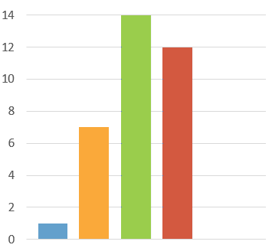

 | 16-24 | 1
 | 25-34 | 7
 | 35-49 | 14
 | 50-64 | 12
 | 65-74 | 0
 | 75+ | 0

2. Which of the following statements best describes your ability to understand Gaelic?

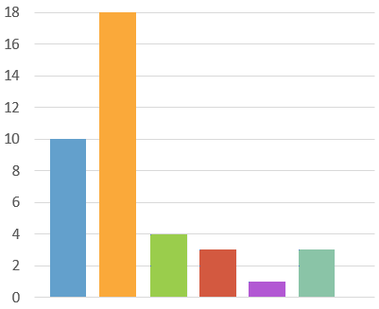
 | I do not yet understand an G… | 10
 | I can understand simple greeti… | 18
 | I can pick up the general mea… | 4
 | I can understand most normal… | 3
 | I can understand fluent Gaelic… | 1
 | I can understand fluent Gaelic… | 3

3. Which of the following statements best describes your ability to speak Gaelic?
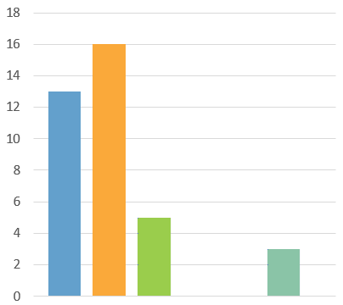

 | I do not yet speak any Gaelic | 13
 | I can exchange simple greetin… | 16
 | I can take part in basic conver… | 5
 | I can take part in daily conver… | 0
 | I can comfortably take part in… | 0
 | I can comfortably discuss subj… | 3

4. Which of the following statements best describes your ability to read Gaelic?

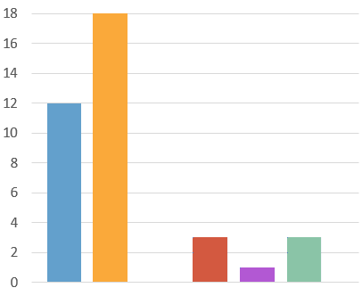
 | I cannot yet read any Gaelic | 12
 | I can understand a few words… | 18
 | I can understand Gaelic childr… | 0
 | I can understand Gaelic novels… | 3
 | I can understand and read Ga… | 1
 | I can understand Gaelic terms… | 4

5. Do you use Gaelic at home?
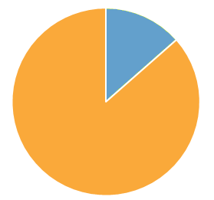

 | Yes | 5
 | No | 32

6. Do you use Gaelic at home?

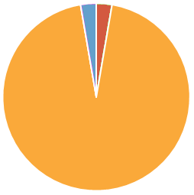
 | Gaelic only | 1
 | English only | 35
 | Gaelic and English Equally | 0
 | Other | 1

7. How frequently do you use Gaelic, including reading, writing and/or speaking it?

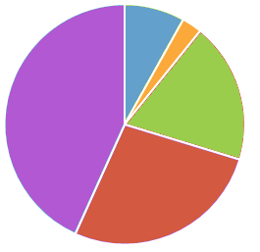
 | A lot | 3
 | Fairly often | 1
 | Occasionally | 7
 | Rarely | 10
 | Not at all | 16

8. Did you attend any of the following during your education? Please select all that apply.

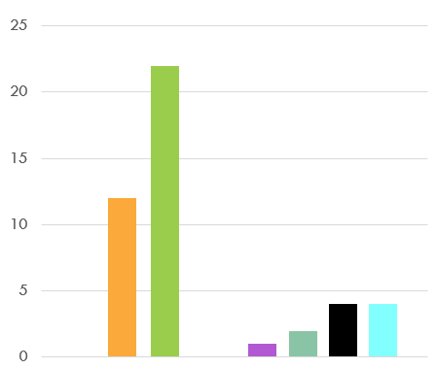
 | Sgoil-àraich | 0
 | English-language playgroup | 12
 | English-medium primary | 22
 | Gaelic-medium Education pri… | 0
 | Gaelic-medium Education sec… | 1
 | Collage/university course abo… | 2
 | Other | 4
 | Other | 4

9. Do you use Gaelic at home?
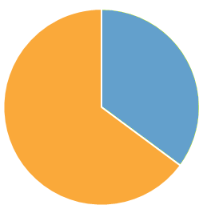

 | Yes | 13
 | No | 24

10. In which of these ways if any, do you ever watch, read or listen in the Gaelic language nowadays? Please tick all that apply.

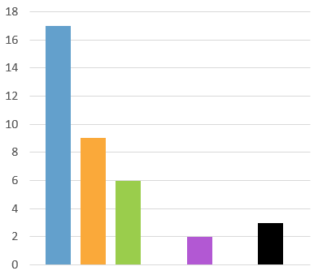
 | Watching TV | 17
 | Listening to radio | 9
 | Using social media | 6
 | Watching DVDs | 0
 | Viewing the internet | 2
 | Reading novels | 0
 | Reading other materials | 3

11. Are you learning Gaelic either informally at home or attending classes?
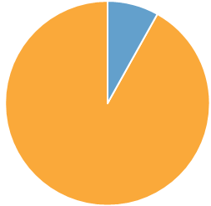

 | Yes | 3
 | No | 34

12. Have you ever attended Gaelic training which was paid for by the Commission?
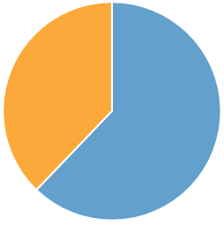

 | Yes | 23
 | No | 14

13. Would you be interest ed in further t raining to develop your Gaelic skills?
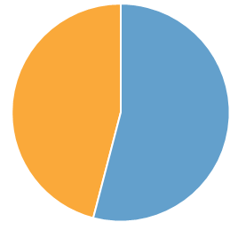

 | Yes | 20
 | No | 17

14. Would you like to be able to practice speaking Gaelic more within the office?

 | Yes | 20
 | No | 17

15. Would you like fluent Gaelic speaking staff to initiate conversations with you in Gaelic?
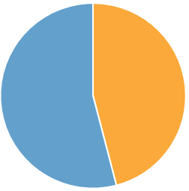

 | Yes | 15
 | No | 22

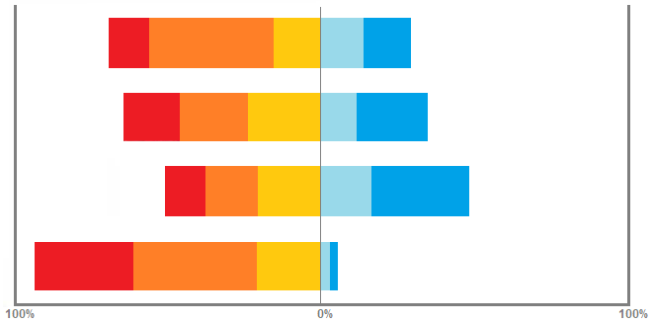
16. How would you rate the importance of Gaelic to each of the following?

 | Very important |  | Fairly important |  | Neither important or unimportant |  | Fairly unimportant |  | Very unimportant |  | Don’t Know

To your national identity as a Scot or as a person living in Scotland?
To your local identity?
To your own personal identity?
To the corporate identity of the Crofting Commission?

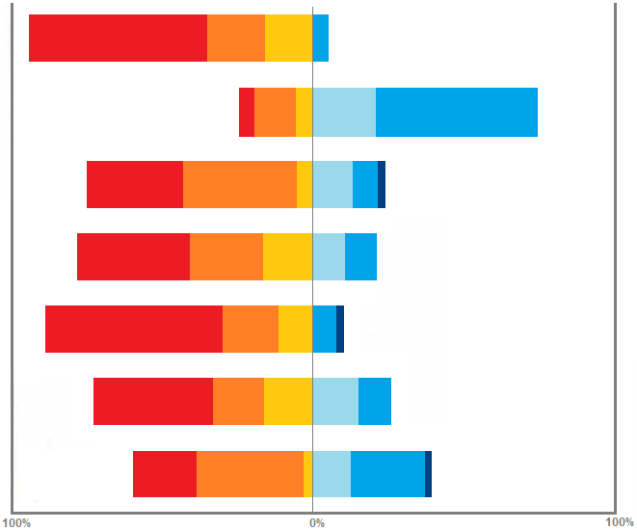
17. How would you rate the importance of Gaelic to each of the following?

 | Strongly agree |  | Agree slightly |  | Neither agree or disagree |  | Disagree lightly |  | Disagree strongly |  | Don’t Know

Gaelic is an important part of Scottish culture.
Gaelic is not relevant for Scotland today.
Gaelic makes a valuable contribution to promoting Scotland’s identity abroad.
The use of Gaelic should be supported and encouraged throughout Scotland.
It is important that Scotland does not lose its Gaelic language traditions.
More should be done to encourage and promote Gaelic in Scotland.
Gaelic is only relevant in certain parts of Scotland, such as the Western Isles.

18. Do you have any suggestions on how to further improve the use of Gaelic within the Crofting Commission?

35 |  | Latest responses
Responses |  | “Not at the present time.”  “Make it mandatory that everyone learns the basic greetings etc instead of as…  “No”

Do you have any suggestions on how to further improve the use of Gaelic within the Crofting Commission?
The switchboard phone can be answered in Gaelic - whether or not the individual can continue in Gaelic or not.
Answering all calls with a Gaelic welcome.
I don't think there should be pressure on individuals to learn Gaelic or financial pressure put on the organisation to meet unrealistic requirements with regards to…
No. You can't force people to speak it if they don't want to.
Additional Training.
Employ native Gaelic speakers.
No, I think we do pretty well and the fact we have fluent Gaelic speakers within the CC and the wider building, means we can hear and practice language skills if we…
Training sessions for staff.
I think what has been provided so far with regards to Gaelic training has been excellent and I hope that we can continue to utilise the skills that have been learnt so far to consolidate this training else it will be forgotten.
more informal, fun uses and exchanges.
Ideally, I would want to see a greater number of fluent Gaelic speakers working for the Commission. Have we ever explored with BnG the possibility of…
People attending the Gaelic courses maybe each put a word on the notice board which every learner could practice.
Perhaps as part of individual's PLPs, the option for staff to further continue and build on Gaelic previously learned by undertaking further courses, whether that be a tutor visiting the Commission or an external course through say UHI? I feel if staff are keen to further develop their language skills, this will also aid the...
Would we want to start using it more with the telephone?
~ The Commission voicemail currently starts with 'Failte gu Comisean na Croiterachd' should it also end with Gaelic e.g. moran taing instead of the current thank you?
Perhaps a Gaelic course through the Skye college.
I don't have any suggestions, but believe that it should be properly considered with input from those who speak the language.
make it mandatory that everyone learns the basic greetings etc instead of asking people if they want to!

